Dis-Asia-Russia-Lake Baikal-Malta Village-Venus Figurine-8.5 cm

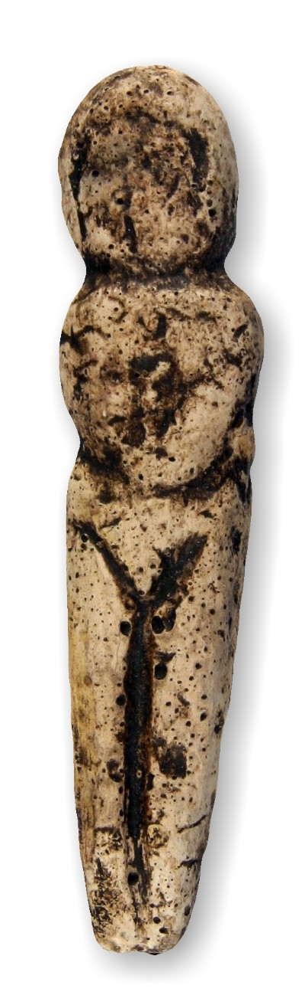

Formal Label:

Accession Number:

Date or Time Horizon:

Geographical Area: Ma’lta village, Lake Baikal, Siberia, Russia

Cultural Affiliation:

Media:

Dimensions: H 8.5 cm

Weight:

Provenance: